Linear Regression
Hypothesis function:
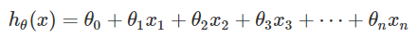

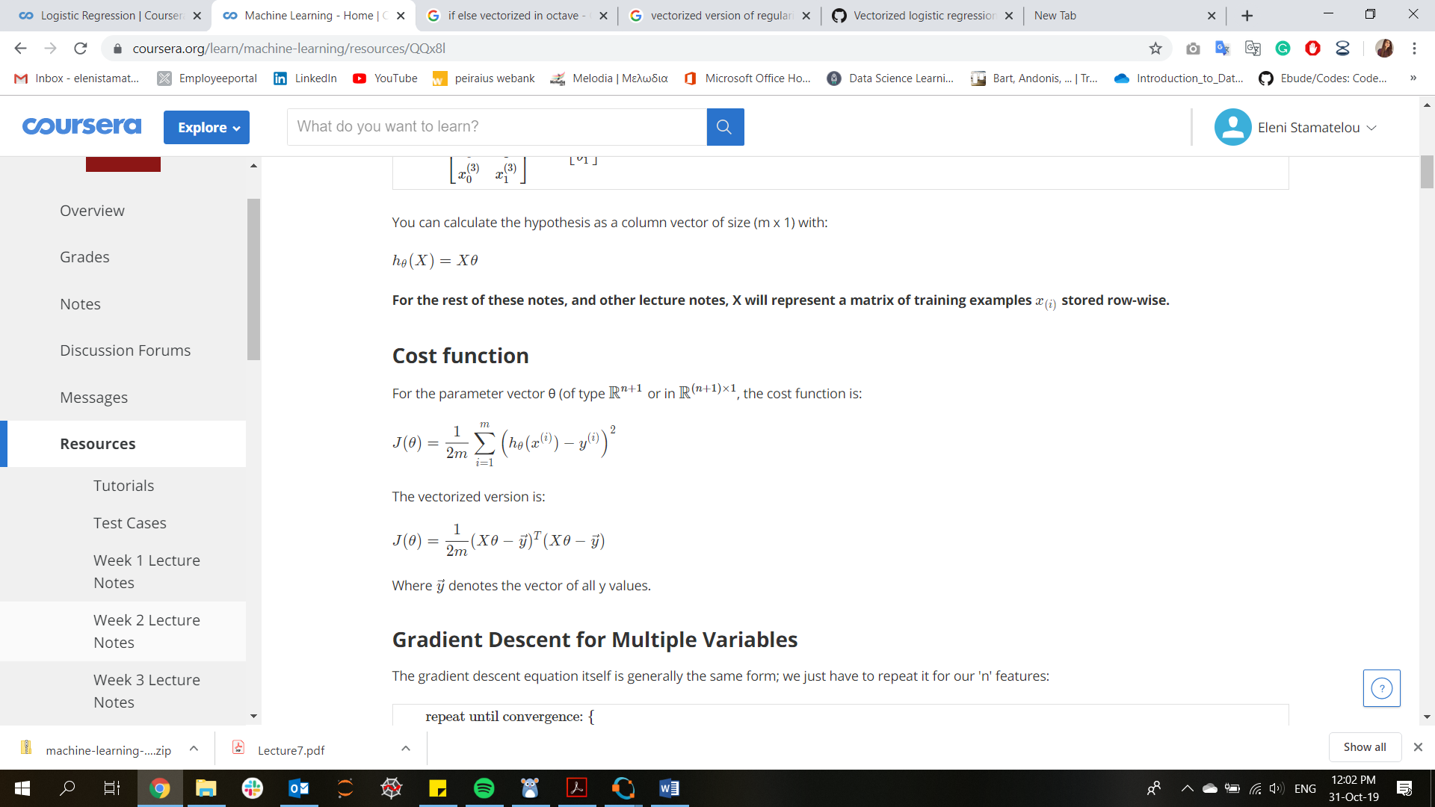
Cost function:

Gradient Descent:
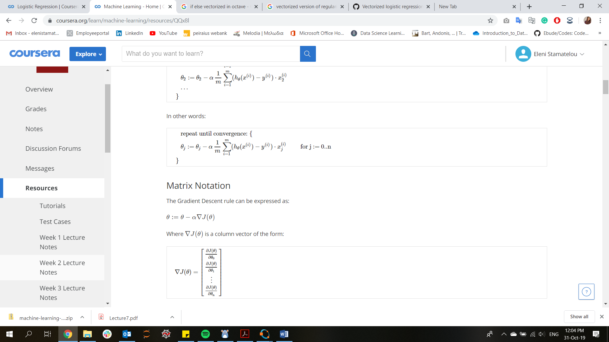

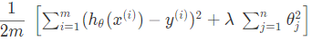
Regularization:

Logistic Regression
Hypothesis function:
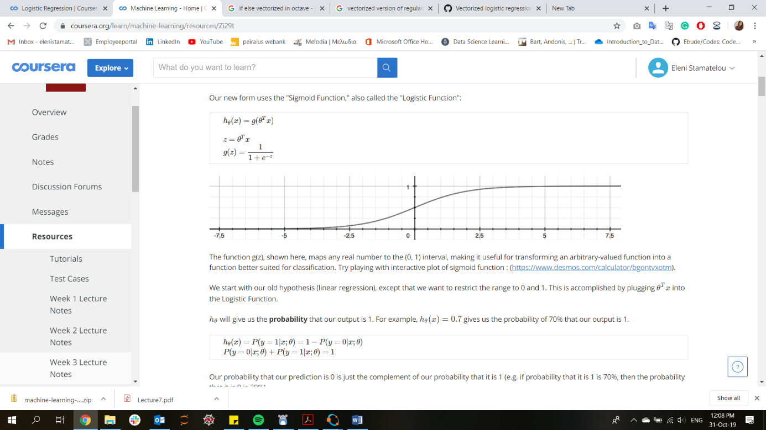

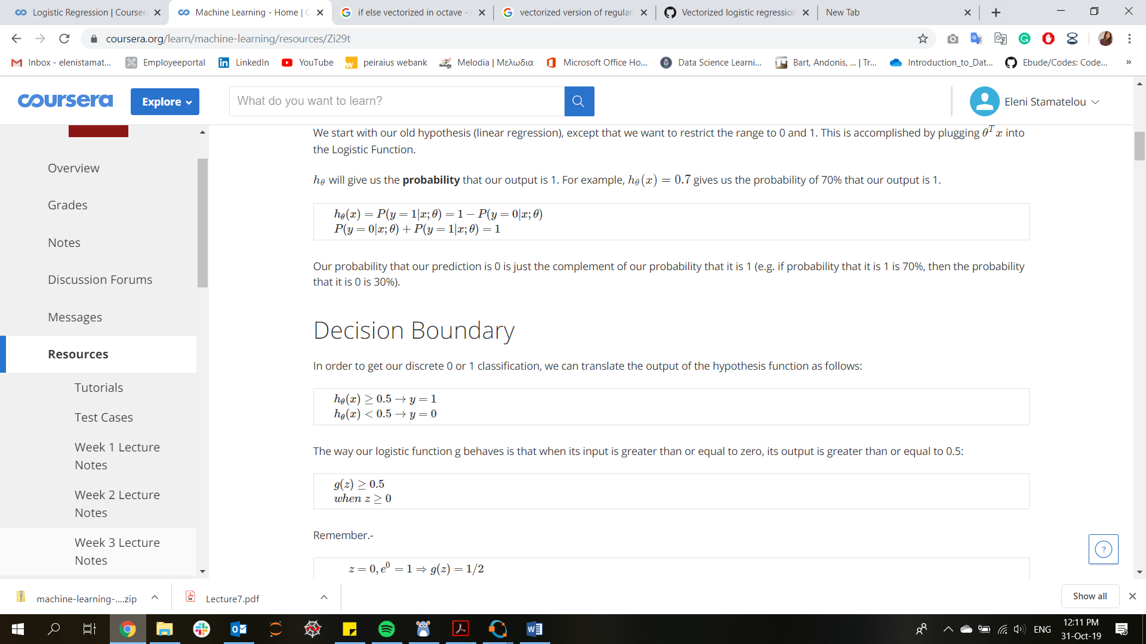
Cost function:
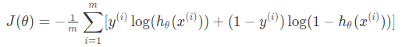

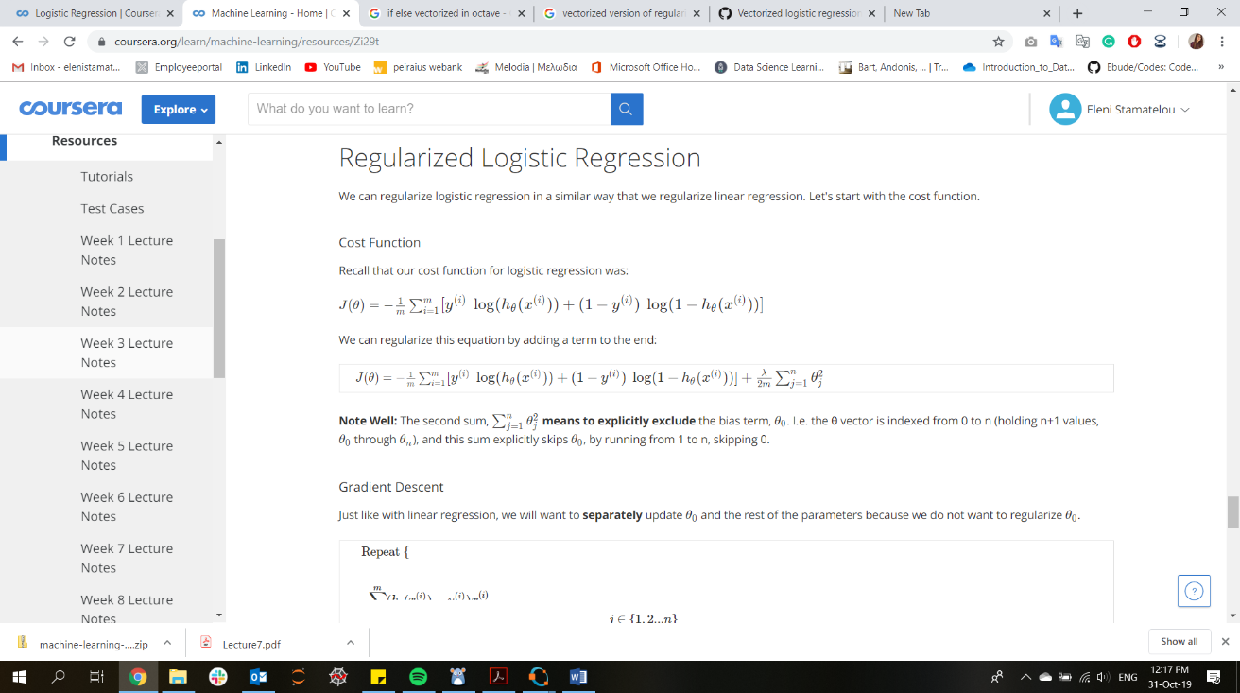
Regularization:

Neural Networks
Hypothesis function – Forward propagation:
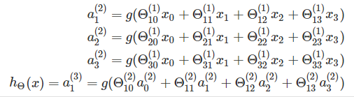

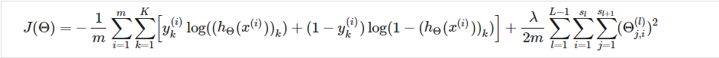
Cost Function + Regularization:
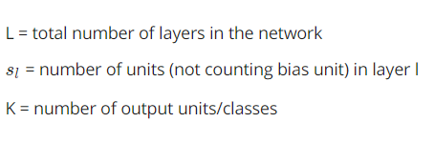

Backpropagation: (neural-network terminology to find the derivatives of cost function)
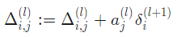
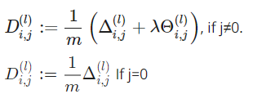
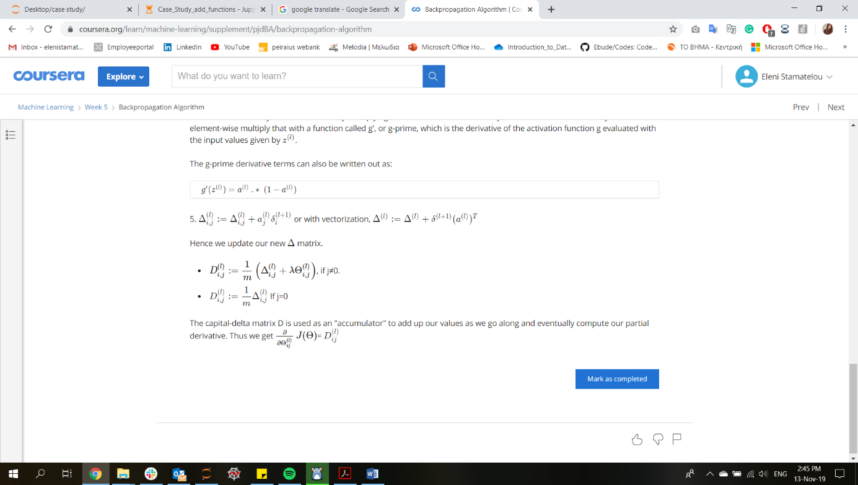
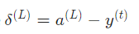
Derivatives
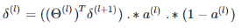
Final layer
Rest of layers
STEPS
- Pick a network architecture
- Random weight (Θ) initialization
- Forward propagation to get hypothesis function h(x) (inside for loop/per sample)
- Define Cost Function J(θ)
- Backpropagation to compute partial derivatives
- Gradient Checking to validate backprop (inside for loop/per sample)
- Gradient descent or other optimization algorithm to minimize cost function + define weights (Θ)
Support Vector Machines

Hypothesis function: 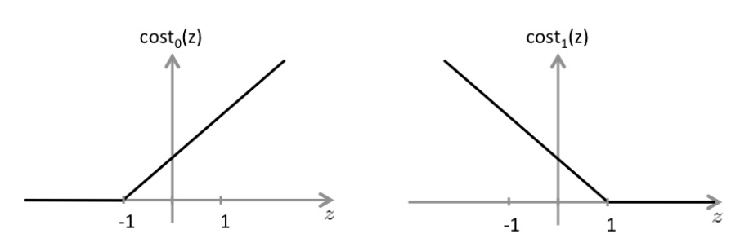
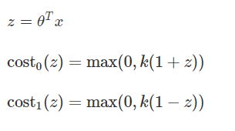

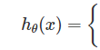
= (0, 1) for class y = 0

= (0, 1) for class y = 1

Cost function:

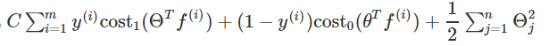
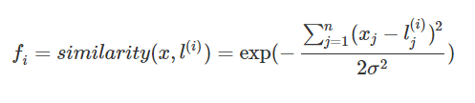

Collaborative filtering

j = user , i = movie ,
Θ = users rating for each feature
X = movies’ rating for each feature

Cost Function:

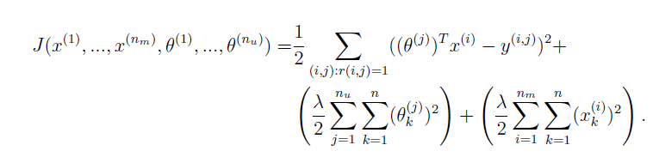
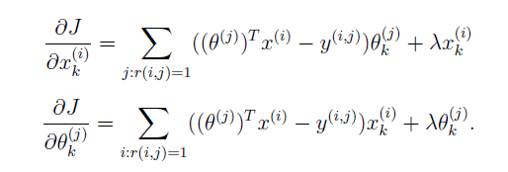Gradient descent:

